Topic 6 Worksheet 3
Reflecting on Research
‘Knowledge workers create knowledge and have know-how about customer and client expectations, research methods, sales trends, production methods, industry practice and strategic direction’ (Dwyer 2016).
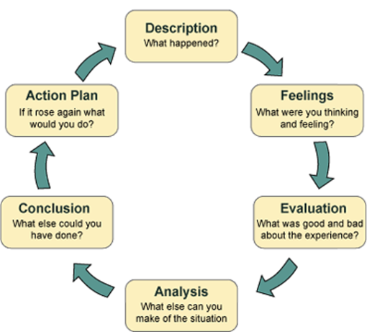
From Gibbs, G 1988, Learning by doing: A guide to teaching and learning methods, Oxford Polytechnic.
Task:
Use Gibbs’ Reflective Cycle (1988), as shown on the previous page, to describe when you have incorporated research into your study, but also as the evaluation and action planning stages of this cycle, what has this taught you about future practice, either from a positive or a negative experience?
Develop your ideas using the cycle in the previous figure to structure this Discussion Board entry.

